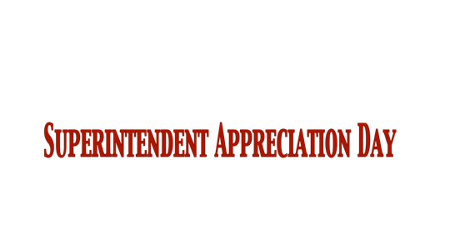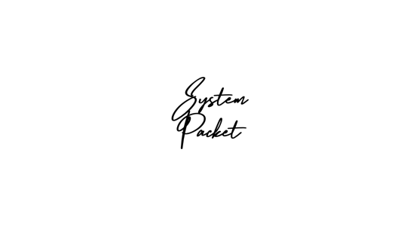

***Memo to School Board from the Chairman.***

Use the sample memo provided or create your own to encourage school board participation in the upcoming Superintendent Appreciation Day. See page 2 for a sample memo.

***Resolution of Appreciation.***

This sample resolution declares Thursday, November 16, 2023 as Superintendent Appreciation Day. See page 3 for the sample Resolution.

**Presentation of the Signed Resolution.**

Have a copy of the Resolution prepared for the Board Chair to present to the Superintendent after the Resolution is adopted. See page 4 for more information.

***News Release.***

Modify the news release or write your own to send to local media outlets. Include a photo of the superintendent to send with the news release. See page 5 for sample news release.

***Website Poster.***

Upload the poster on your system website to inform the community of the upcoming appreciation day. See page 6 for the poster.

***Presentation to the Board.***

After Superintendent Appreciation Day, prepare a presentation for the board about the appreciation day. See page 7 for more information.



To: Board of Education

From: Chairman of the School Board

Re: Superintendent Appreciation Day

Date: November ______, 2023

As a part of the Utrust Appreciation Program, our school district honors and recognizes several groups of employees throughout the year. The next group of employees to be recognized is superintendents. I recommend that our board designate Thursday, November 16, 2023 as Superintendent Appreciation Day.  The theme is Thanksgiving Express.

Attached to this Memo is the Resolution of Appreciation.  I recommend adopting the Resolution to officially honor our Superintendent.

Participating in this program provides positive publicity for our school district, and it is a fun and exciting opportunity to honor employees. I encourage each board member get involved in the Thanksgiving Express-themed activities that are planned and join the rest of the system in honoring our Superintendent.  Every school is asked to participate in a charity drive in honor of the Superintendent.  Please consider participating in the drives that will benefit others in need.



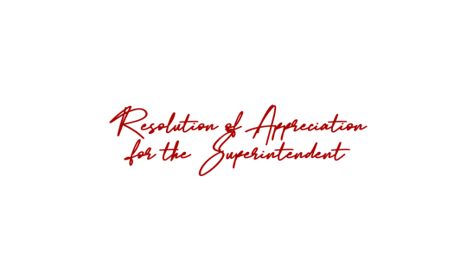

WHEREAS, our Superintendent has upheld the distinction and honor of his/her position by making decisions based on integrity and honesty and by practicing effective leadership; and

WHEREAS, our Superintendent creates a budget for our district to provide the resources necessary for our schools within the confinements of the budget; and

WHEREAS, our Superintendent strives for excellence in every aspect of his/her job and encourages his staff and students to do the same; and

WHEREAS, he/she provides support for the programs at the schools, helping students and faculty grow and develop academically and socially, and has built support within the community for our school system.

THEREFORE, BE IT RESOLVED, that the Board of Education officially recognizes the continued services of _________ to the students of _____________ Schools and extends its appreciation for his/her work to enhance the learning environment of the students in our district;

BE IT FURTHER RESOLVED, that the _____________ Board of Education hereby declares November 16, 2023 as Superintendent Appreciation Day in ___________ Schools;

BE IT FURTHER RESOLVED, that school principals take necessary measures to implement the Utrust Appreciation Program in their school by recognizing our Superintendent this month.

_______________________________ ______________________________

Chairman Vice-Chairman



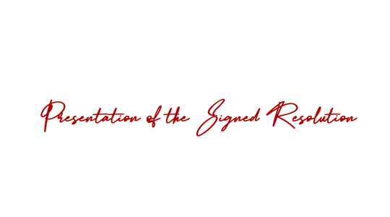

Have a copy of the Resolution of Appreciation for the Superintendent prepared for the Board Chair to present to the **Superintendent** after the Resolution is adopted.

You may want to give board members an opportunity to make positive comments about the Superintendent.

Arrange for a photo of the presentation with other board members and the Superintendent as the Board Chair presents the Resolution.

Send a copy to the media.

Present a signed Resolution of Appreciation to the Superintendent with any additions or corrections made by the board.





FOR IMMEDIATE RELEASE

DATE: _______________

The ______________ School Board passed a Resolution this week declaring Thursday, November 16, 2023 as Superintendent Appreciation Day. Therefore, students across the system will be using the Thanksgiving Express theme to show appreciation to Superintendent __________________.

Various activities are being planned to honor the Superintendent by conducting a charity drive to help families in need in the community.  Student members of the A-Team at each school are responsible for leading the way in showing appreciation and getting all other students involved. By helping others and giving their time and effort, the students will be saying thanks to their Superintendent for the example he/she sets in making the welfare of others a priority.

In a society where appreciation is often overlooked, the students of __________________ are learning first-hand what it means to have an attitude of gratitude. There are eight different appreciation days scheduled throughout the year to honor and celebrate various employees. Each of the appreciation days are a part of the Utrust Appreciation Program designed to teach students about gratitude using fun themes to show thanks. Superintendent Appreciation Day is the third appreciation day we have celebrated.

School Board Chairman _______________ said “We are so grateful for Superintendent _______________. We want to be the first to say thank you for a job well done. We believe participating in the charity drives in the schools is a great way to honor our Superintendent.

Although the appreciation days are led by students, there are also opportunities for the community to join in. Please express your gratitude to the Superintendent, either verbally or in writing.

(Note: Attach a copy of the signed Resolution of Appreciation and a photo of the chair presenting it to the Superintendent with other board members. This will increase the likelihood that the local newspaper and social media will cover the story.)



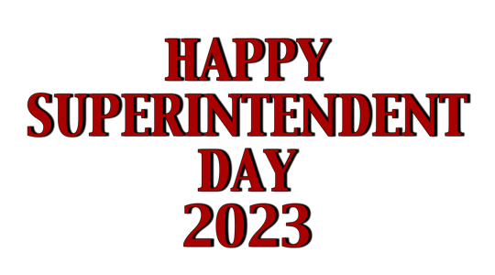

\



Prepare a short presentation for the next

Board meeting informing the school board members of the great things that happened on **Superintendent Appreciation Day** using the theme **Thanksgiving Express**.

Choose the most outstanding charity drive celebrations that happened in your school district and highlight those schools.

In the 5-minute presentation consider including pictures, videos and quotes from students and coordinators.

The goal of the presentation is to inform the board members of the importance of the program, and how it is making a difference in the students and staff in the schools. It also gives board members a chance to commend students in their appreciation efforts and to join in celebrating the honorees.

Additionally, it enhances public opinion of and public support for students and the schools they attend when they realize how students are showing appreciation for school staff members.

