Image

**Resolution of Appreciation.** This sample resolution declares February 8, 2024 as Principal Appreciation Day. See page 3 for the Resolution.

**Memo to School Board from Superintendent.**  Use the sample memo provided or create your own to encourage school board participation in the upcoming Principal Appreciation Day. See page 2 for the memo.

**Presentation of the Signed Resolution.** Email a copy of the signed Resolution to the school coordinators to post in the schools for the Principals to see. Or, enlist school board members to present a signed copy of the Resolution to each Principal in their districts. See page 4 for more information.

**News Release.** Send the included news release (or write your own) to local media outlets. See page 5 for the news release.

**Website Poster.** Use your system website to promote Principal Appreciation Day. Copy and paste the artwork provided or create your own. See page 6 for the web poster.

**Presentation to the Board.** Prepare a short presentation of all the appreciation day activities to promote the Utrust Appreciation Program. See page 7 for more information.



TO: Board of Education

FROM:   Superintendent

RE:         Principal Appreciation Day

DATE:     February ____, 2024

The next appreciation day in the Utrust Appreciation Program is Principal Appreciation Day. It is set for Thursday, February 8, 2024. The theme for the day is Safari.

Attached is the Resolution of Appreciation. Please consider adopting it to honor of the outstanding group of leaders in our school system.

Using the Safari theme, the principals will be honored because their job is not easy. Their responsibilities are extremely important to the success of our school system. They manage to do a lot of tasks well.

Please join me in supporting and participating in the Utrust Appreciation Program. We are looking forward to a successful appreciation day as we express sincere appreciation to our principals and assistant principals for all they do.

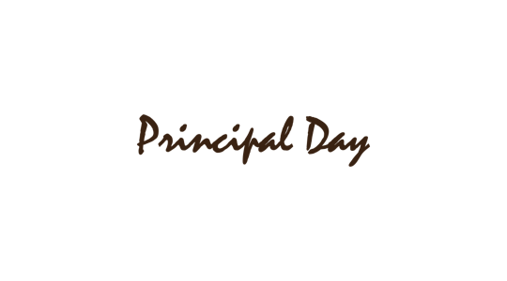

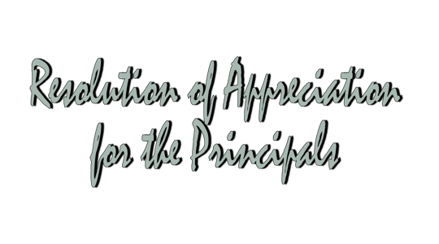

**WHEREAS**, principals and assistant principals have enormous responsibilities and duties including observing, evaluating, policy planning, mentoring and much more; and

**WHEREAS**, principals and assistant principals are instructional leaders who provide direction and support to students, teachers and other school employees in our district: and

**WHEREAS**, our principals establish a vision for our schools and create strategies for getting there; and

**WHEREAS**, principals strive to enhance the learning and working environment for everyone in the school;

**NOW, THEREFORE, BE IT RESOLVED** the _____________ Board of Education hereby adopts February 8, 2024 as Principal Appreciation Day in all of our schools; and

**BE IT FURTHER RESOLVED THAT** the Board expresses deep appreciation to principals and assistant principals in our system and encourages the students and staff to join us in expressing appreciation to the leaders of _____________ Schools.

Approved by the _______________ Board of Education in regular session on ______________, 2024.

Note: Please feel free to change the Resolution as needed as you consider adopting it.

____________________________               __________________________

Superintendent                                        Board Chairman







After the Resolution of Appreciation has been modified by the board and signed by the Superintendent and Board Chairman, email a copy of the school coordinators to post in the schools for the **Principals** to see.

Another option is to enlist school board members to visit each of the schools in his/her district and present a signed copy to each **Principal** on **Principal Appreciation Day**.

Make sure each board member has enough copies for all the **Principals** at his/her school.



FOR IMMEDIATE RELEASE

Date __________________

The students and teachers in __________ school system will come together to honor and celebrate their principals next week. The School Board has passed a resolution declaring February 8, 2024 as Principal Appreciation Day.

Students across the system will be using the Safari theme to honor and thank their principals. Various activities are being planned to let the principals know how much their hard work is appreciated. Student members of the A Team at each school are responsible for leading out in appreciation and getting all the other students involved.

In a society where thanks are often overlooked, the students of __________________ are learning first-hand what it means to have an attitude of gratitude. There are eight different appreciation days scheduled throughout the year to honor and celebrate various employees. Each of the appreciation days are a part of the Utrust Appreciation Program designed to teach students about gratitude using fun themes to show thanks.

Superintendent ___________________________ said, “The principals of _________________School System are the best and we want to lead out in showing appreciation to them for their leadership. We do not take our principals for granted and want to be sure they know how much they mean to us all.”

Although the appreciation days are led by students there are also opportunities for the community to join in. For information on how you can help show gratitude to school employees, contact your local schools or system administrator.

Note: You might want to attach a copy of the resolution and a photo of the chair presenting it to the longest employed Principal. This will help to increase the likelihood that the local newspaper will run the story and be picked up by social media.









Prepare a short presentation for the next Board meeting informing the school board members of the great things that happened on **Principal Appreciation Day** using the **Safari theme**.

Choose a few of the most interesting activities that happened in your school district and highlight them.  In the 5-minute presentation, consider including pictures, videos and quotes from students and coordinators.

The goal of the presentation is to inform the Board members of how the program is making a difference in the students and staff in the schools. It also gives Board members a chance to join in celebrating the **Principals** and to commend students for their appreciation efforts.

Additionally, it enhances public opinion of and public support for students and the schools they attend when they realize how students are showing appreciation for school staff members.