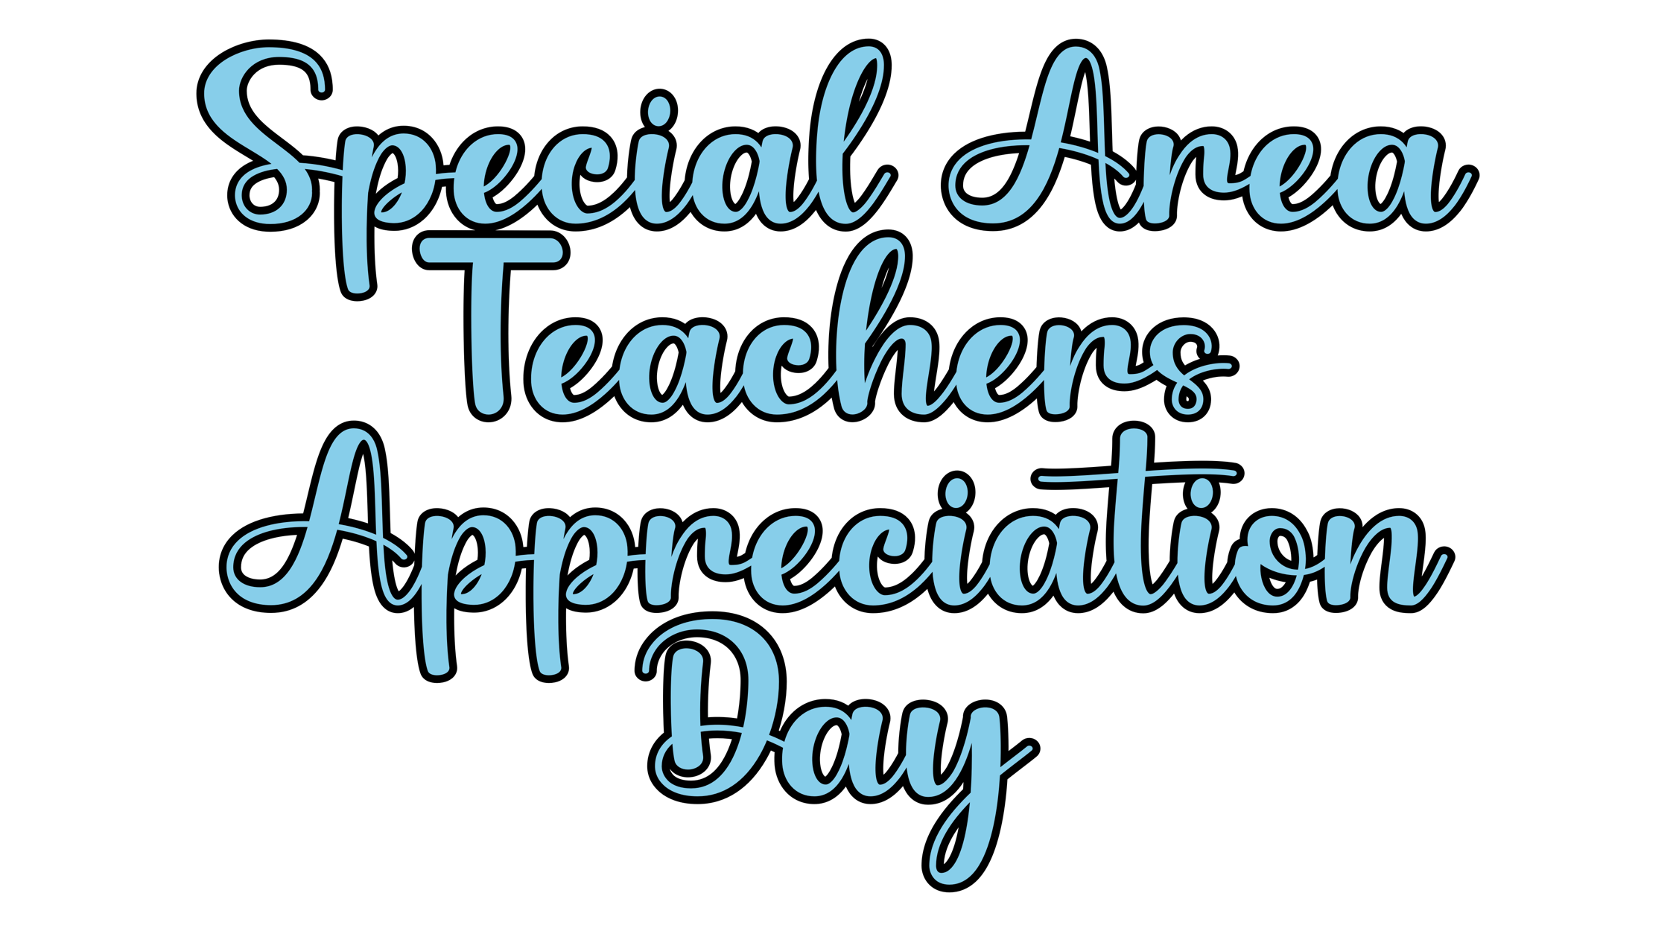

**News Release.** Send the included news release (or write your own) to local media outlets. See page 5 for the sample.

**Website Poster.** Upload the poster on your system website. See page 6 for the poster.

**Board Presentation.** Prepare a short presentation for the board about Special Area Teachers Appreciation Day. See page 7 for more information.

**Memo to School Board.** Use the sample memo provided or create your own to encourage school board participation in the upcoming appreciation day. See page 2 for a sample memo.

**Resolution of Appreciation.** The Resolution declares March 7, 2024 as Special Area Teachers Appreciation Day. See page 3 to view the sample resolution.

**Presentation of the Signed Resolution.** Email a copy of the signed Resolution to school coordinators to post. Or, enlist school board members to present a copy to the honorees. See page 4 for more information.

Special Area Teachers:

Art Teachers

Music Teachers

PE Teachers

Technology Teachers

Speech Teachers

School Counselors

Librarians

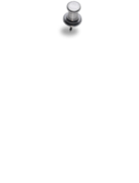

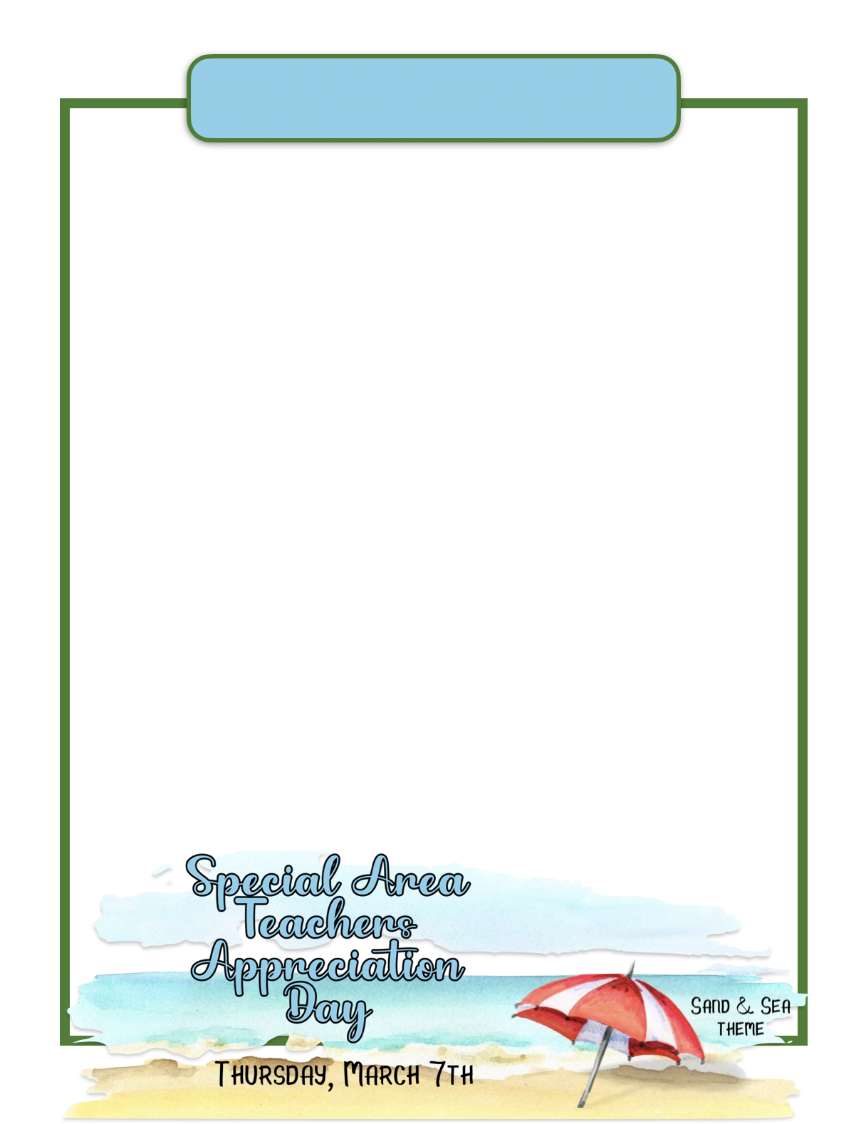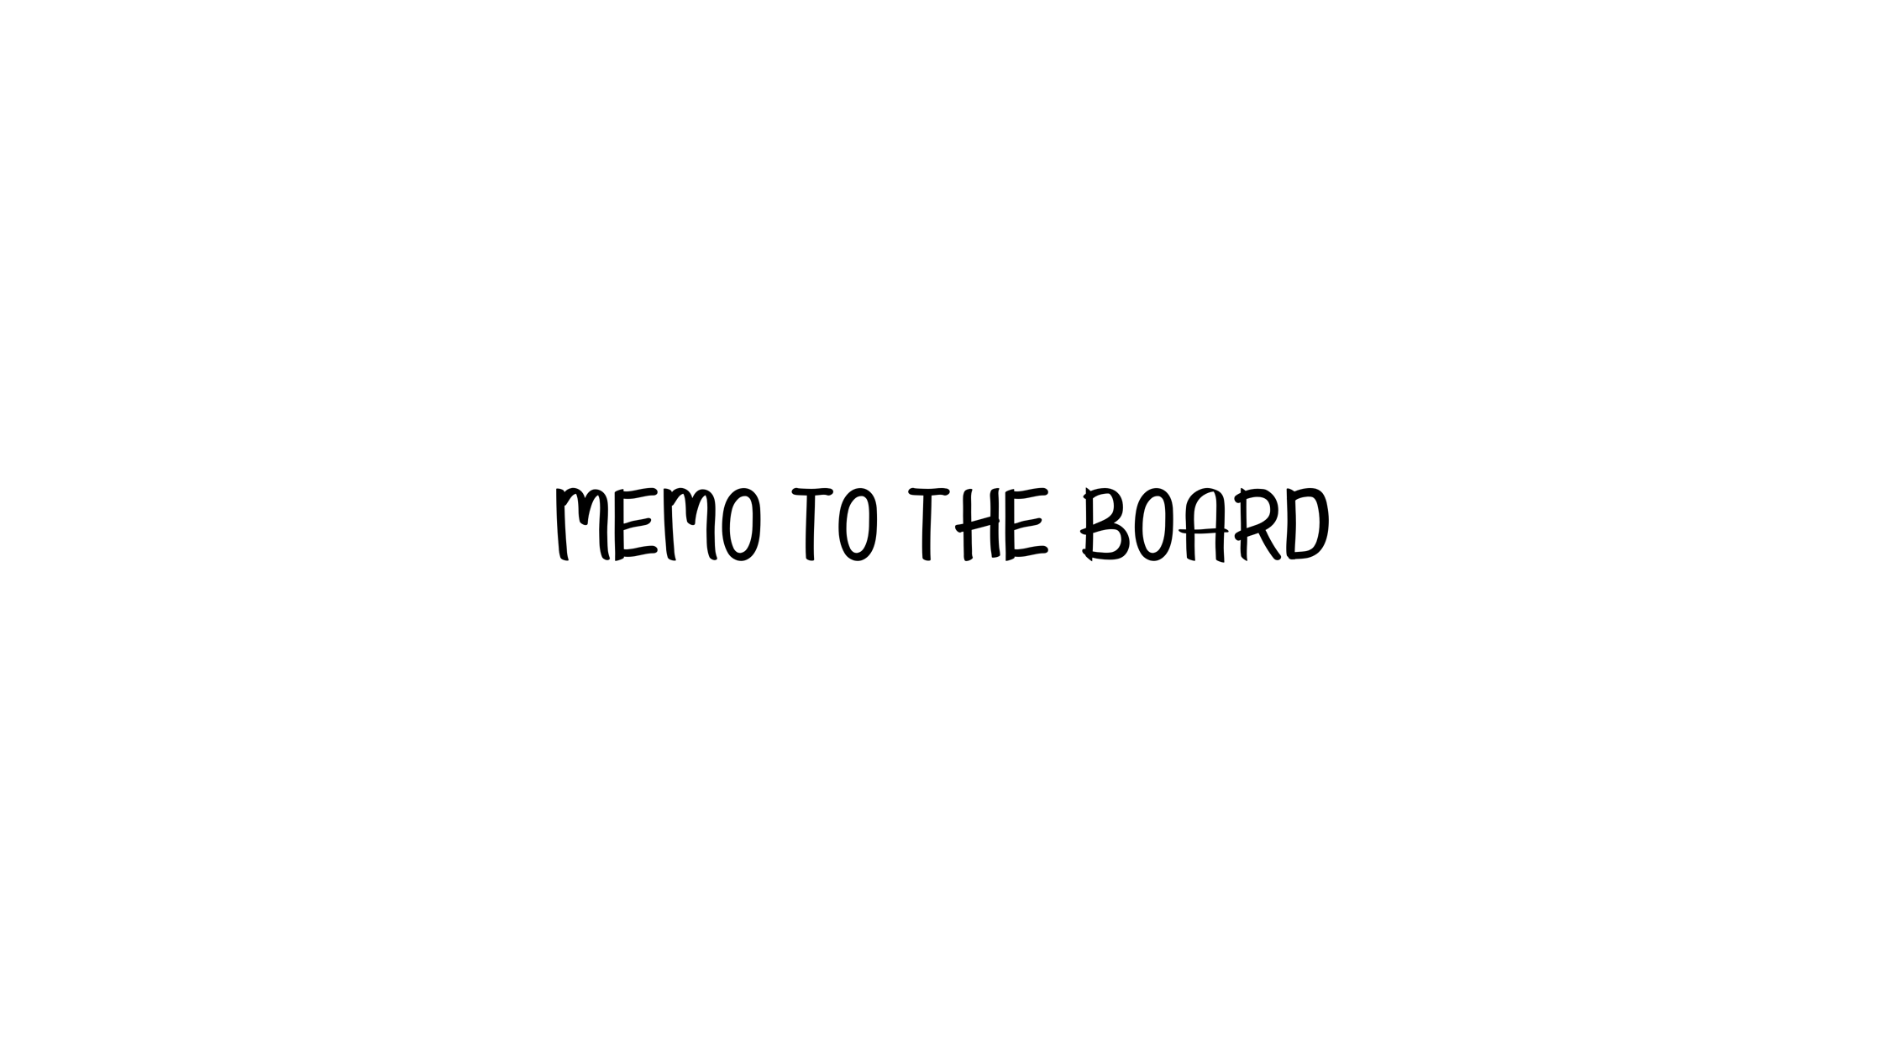

Memo from Superintendent

to Board

To: Board of Education

From: Superintendent

Re: Special Area Teachers Appreciation Day

Date: March __, 2024

The date of March 7, 2024 has been set by Utrust for Special Area Teachers Appreciation Day.  This group includes art teachers, music teachers, PE teachers, technology teachers, speech teachers, school counselors and librarians. (Delete any that are not in your system.)  They are very important to the mental health and welfare of our students.

The theme for this appreciation day is Sand and Sea.  We want to use this fun theme to show these special school employees they are valued and appreciated.  Attached is the Resolution of Appreciation to establish Special Area Teachers Appreciation Day.  Consider adopting the Resolution and setting the date for March 7, 2024.

Please join me in showing appreciation to these special employees by participating in the appreciation celebrations in some way.

Special Area Teachers:

Art Teachers/Music Teachers/PE Teachers/Technology Teachers/Speech Teachers/School Counselors/Librarians

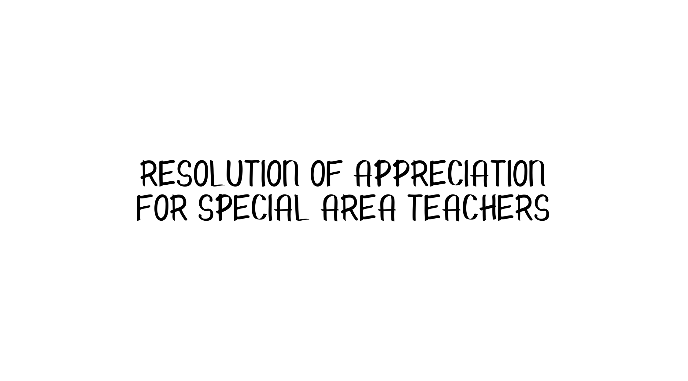

WHEREAS, the ________ School System is dedicated to showing appreciation for our Special Area Teachers and Staff members that include Art Teachers, Music Teachers, PE Teachers, Technology Teachers, Speech Teachers, School Counselors and Librarians;

WHEREAS, the Special Area Teachers in __________ are responsible for the mental health and welfare of our students;

WHEREAS, this group of professionals serve a very important role in providing a variety of special services to our students on a daily basis;

WHEREAS the ________ Board of Education wishes to honor the Special Area Teachers for their commitment and loyalty to their students and schools.

NOW, THEREFORE, BE IT RESOLVED the Board of Education hereby establishes March 7, 2024 as Special Area Teachers Appreciation Day in all _________ Schools; and

BE IT FURTHER RESOLVED the Board of Education expresses appreciation to all the school employees who provide special services in our school system.  We encourage each school and community to recognize these individuals for their role in the success of our school system.

Approved by the _____________ Board of Education in regular session on __________________, 2024.

Note: Please feel free to change the Resolution as needed as you consider adopting it.

___________________________ __________________________

Superintendent Board Chairman

Special Area Teachers:

Art Teachers/Music Teachers/PE Teachers/Technology Teachers/Speech Teachers/School Counselors/Librarians

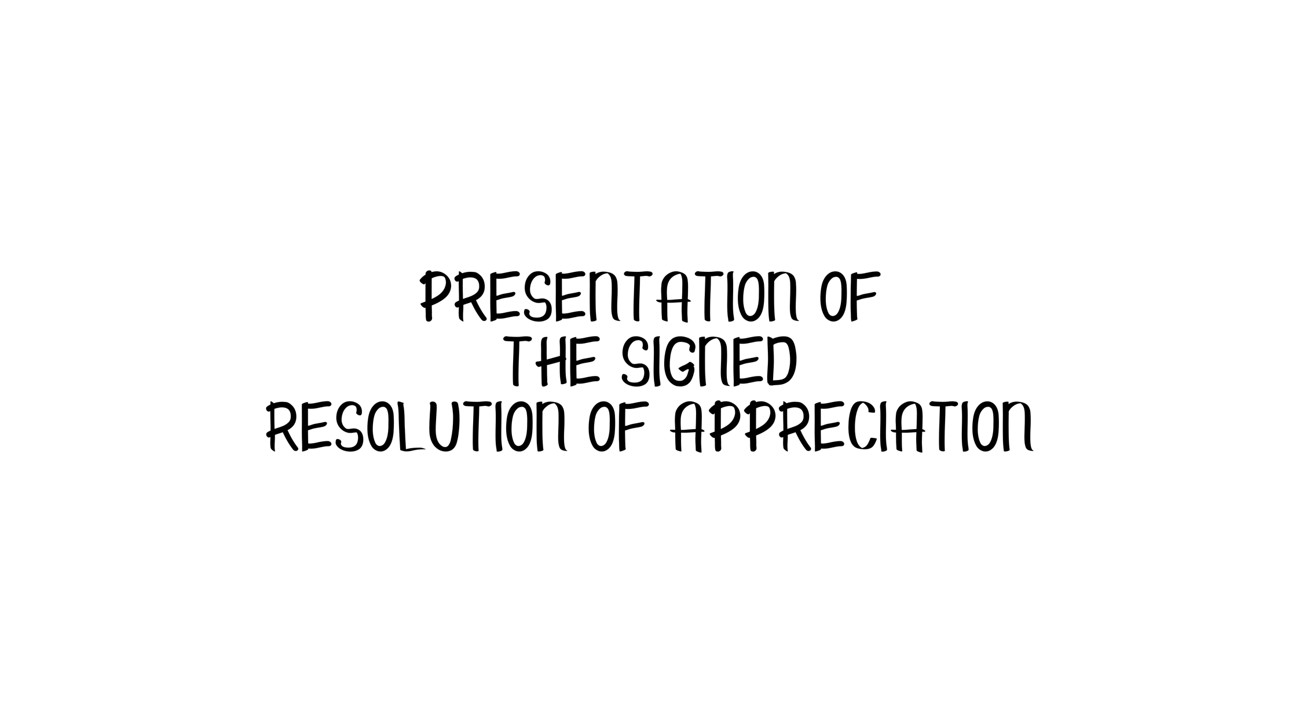

After the Resolution of Appreciation has been signed by the Superintendent and Board Chairman, email a copy of it to each school coordinator to post somewhere in the school for all the **Special Area Teachers** to see.

Another option is to enlist school board members to each visit the schools in his/her district and present a signed copy to each **Special Area Teachers** on **Special Area Teacher Appreciation Day**.

Make sure each board member has enough copies for all the **Special Area Teachers** at his/her school.

Special Area Teachers:

Art Teachers/Music Teachers/PE Teachers/Technology Teachers/Speech Teachers/School Counselors/Librarians



FOR IMMEDIATE RELEASE

DATE: _______________

The month of March means it is time to celebrate and honor the Special Area Teachers of ________________ school system.  The school board passed a Resolution of Appreciation for Special Area Teachers declaring March 7, 2024 as Special Area Teachers Appreciation Day. Celebrations inside the schools led by students will be centered around a Sun and Sea theme.

“Special Area Teachers include the personnel who have specialized roles in schools such as Art Teachers, Music Teachers, PE Teachers, Technology Teachers, Speech Teachers, School Counselors and Librarians (delete any your system does not have). These valuable staff members play a huge role in the success of our school system and we are grateful to have a chance to show them appreciation” says Superintendent ________________________.

The appreciation day for Special Area Teachers is one of eight specified days designated throughout the year to honor school system employees as part of the Utrust Appreciation Program (UAP). The UAP plans and promotes appreciation and is intended to thank employees for their hard work and dedication. The UAP is designed not only to honor the various employees but also to offer an excellent teaching and learning opportunity for students.

For information on how you can help show gratitude to school employees, contact your local schools or system administrator.

Note: You might want to attach a copy of the resolution and a photo of the chair presenting it to the longest employed Special Area Teacher. This will help to increase the likelihood that the local newspaper will run the story and be picked up by social media.

Special Area Teachers:

Art Teachers/Music Teachers/PE Teachers/Technology Teachers/Speech Teachers/School Counselors/Librarians

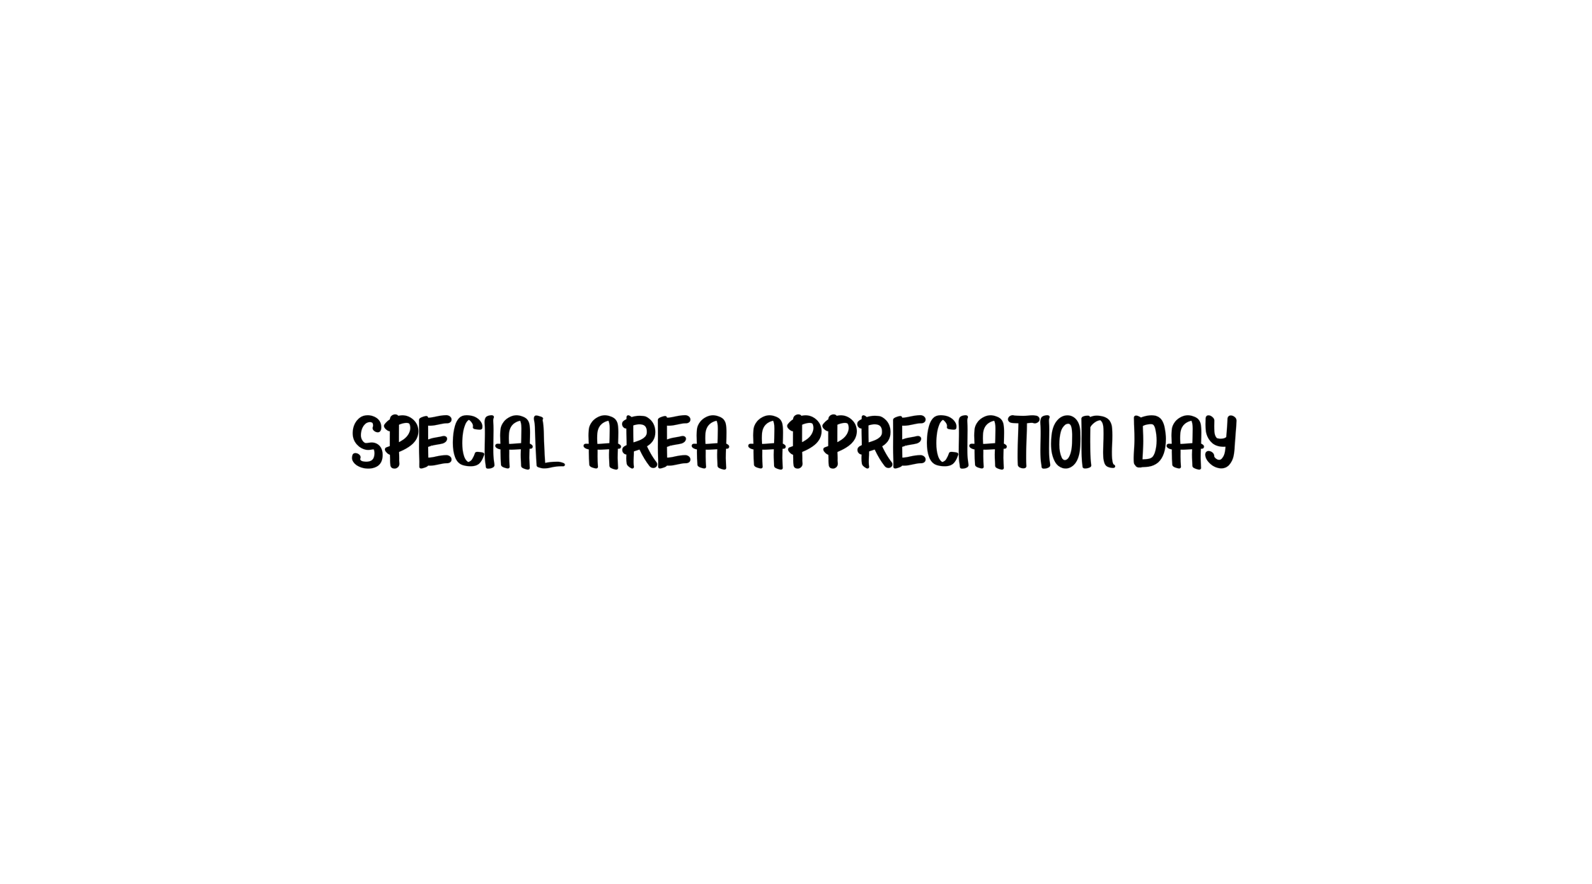

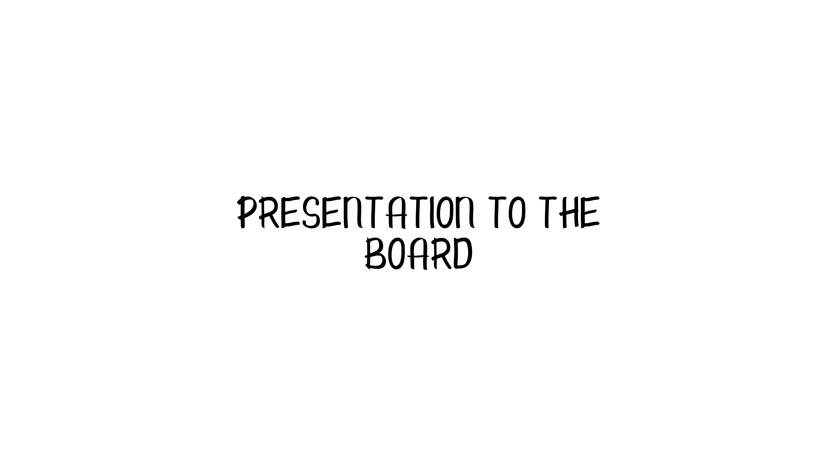

Prepare a short presentation for the next Board meeting informing the school board members of the great things that happened on **Special Area Teachers Appreciation Day** using the **Sun and Sea theme.**

Choose a few of the BEST activities that happened in your school district and highlight them in the 5-minute presentation. Include pictures, videos and quotes from students and coordinators.

The goal of the presentation is to inform the board members of how the program is making a difference in the students and staff in the schools. It also gives board members a chance to join in celebrating the **Special Area Teachers** and to commend students for their appreciation efforts.

Additionally, it enhances public opinion of and public support for students and the schools they attend when they realize how students are showing appreciation for school staff members.

Special Area Teachers:

Art Teachers/Music Teachers/PE Teachers/Technology Teachers/Speech Teachers/School Counselors/Librarians